* COMPUTER NETWORKING PROJRCT REPORT 2024.
* ***NETWORK DESIGN FOR COMSATS UNIVERSITY OF ISLAMABAD:***
* Here we are going to design a network model for Comsats University of Islamabad .
* In this organization total eight departments working, namely UIIT, UIMS , DVM , ELECTRICAL ENGINEERING , MECHNICAL ENGINEERING ,BIOLOGY LAB , CHEMISTRY LAB and PHYSICS LAB .
* ***This organization has an 3 pcs in UIIT,3 pcs in UIMS ,3 pcs in , 3 pcs ELECTRICAL ENGINEERING , 3pcs MECHNICAL ENGINEERING , 3 pcs in DVM , 2 pcs BIOLOGY LAB , 2 pcs CHEMISTRY LAB and 2pcs PHYSICS LAB .***
* ***Total pcs : 30***
* ***Total router : 8***
* ***Total switchs : 11***
* ***We have use the C class IP address 192.168.10.1 - 192.168.110.3 to configure the PCs and used different default gateway for all the departments to make them different over the router.***
* ***We have also used 11 routers.First 8 routers for static and dynamic routing to connect the 8 switches (namely 29611, it has 3 gigabit ports to connect about 8 switches) and we used the Copper Straight through wire to connect the PCs to switches and then switches to the router.***
* ***Operations Performed On Project:***
* ***Static routing.***
* ***Dynamic routing.***
* ***Vlan with respect to trunk and switchport.***

ORGANIZATION REQUIREEMNT:

|  |  |  |  |  |  |
| --- | --- | --- | --- | --- | --- |
| DEPARTMENTS | | | REQUIREMENT | | |
| UIIT | | | 3 PCS | | |
| UIMS | | | 3 PCS | | |
| DVM | | | 3 PCS | | |
| ELECTRICAL ENGINEERING | | | 3PCS | | |
| MECHNICAL ENGINEERIING | | | 3PCS | | |
| BIOLOGY LAB | | | 2 PCS | | |
| CHEMISTRY LAB | | | 2PCS | | |
| PHYSICS LAB | | | 2 PCS | | |
|  |  |  | |  |  |
| S .NO | DEPARTMENTS | IP ADDRESS | | DEFAULT GATEWAY | SUBNET MASKS |
|  |  |  | |  |  |
| 1  2  3 | UIMS | 192.168.10.1  192.168.10.2  192.168.10.3 | | 192.168.10.4  192.168.10.4  192.168.10.4 | 255.255.255.0  255.255.255.0  255.255.255.0 |
| 4  5  6 | UIIT | 192.168.20.1  192.168.20.2  192.168.20.3 | | 192.168.20.4  192.168.20.4  192.168.20.4 | 255.255.255.0  255.255.255.0  255.255.255.0 |
| 7  8  9 | DVM | 192.168.30.1  192.168.30.2  192.168.30.3 | | 192.168.30.4  192.168.30.4  192.168.30.4 | 255.255.255.0  255.255.255.0  255.255.255.0 |
| 10  11  12 | MECHNICAL ENGINEERING | 192.168.40.1  192.168.40.2  192.168.40.3 | | 192.168.30.4  192.168.30.4  192.168.30.4 | 255.255.255.0  255.255.255.0  255.255.255.0 |
| 13  14  15 | ELECTRICAL ENGINEERING | 192.168.80.1  192.168.80.2  192.168.80.3 | | 192.168.80.4  192.168.80.4  192.168.80.4 | 255.255.255.0  255.255.255.0  255.255.255.0 |
| 16  17  18 | BIOLOGY LAB | 192.168.120.1  192.168.120.2  192.168.120.3 | | 192.168.120.4  192.168.120.4  192.168.120.4 | 255.255.255.0  255.255.255.0  255.255.255.0 |
| 19  20  21 | CHEMISTRY LAB | 192.168.100.1  192.168.100.2  192.168.100.3 | | 192.168.100.4  192.168.100.4  192.168.100.4 | 255.255.255.0  255.255.255.0  255.255.255.0 |
| 22  23  24 | PHYSICS LAB | 192.168.110.1  192.168.110.2  192.168.110.3 | | 192.168.110.4  192.168.110.4  192.168.110.4 | 255.255.255.0  255.255.255.0  255.255.255.0 |
|  |  |  | |  |  |

***VLAN CREATION .***

***We have create six vlan with the help of two switches.***

1. ***Vlan 10 shows hr .***
2. ***Vlan 20 shows accounts .***
3. ***Vlan 30 shows finance .***

|  |  |  |
| --- | --- | --- |
| ***S.NO*** | ***VLAN NO*** | ***IP ADDRESS*** |
| ***1*** | ***10*** | ***192.168.120.1***  ***192.168.120.2***  ***192.168.120.3*** |
| ***2*** | ***20*** | ***192.168.130.1***  ***192.168.130.2***  ***192.168.130.3*** |
| ***3*** | ***30*** | ***192.168.140.1***  ***192.168.140.3***  ***192.168.140.2*** |

* ***SCREENSHOT OF NETWORK:***

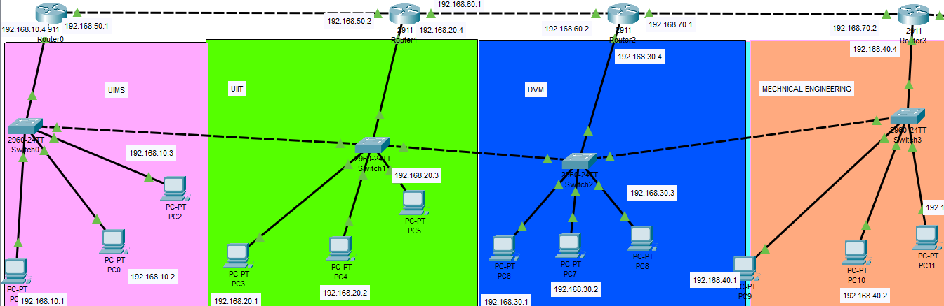

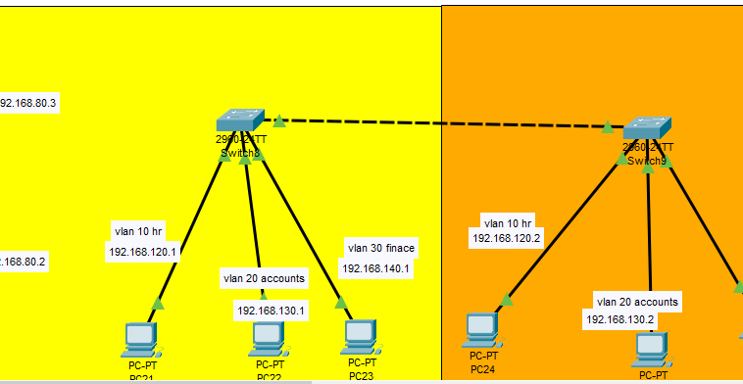

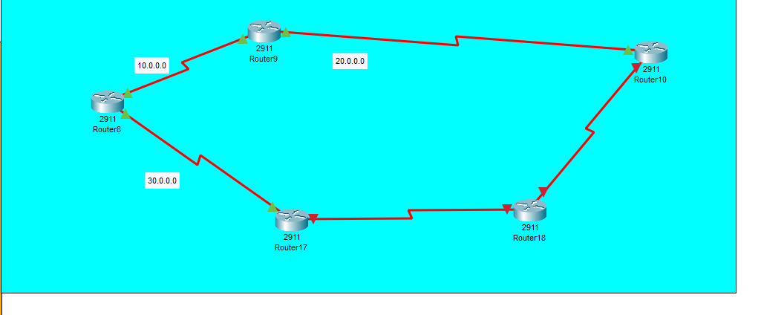

* ***DIFFERENT SYSTEM RESPONSE:***

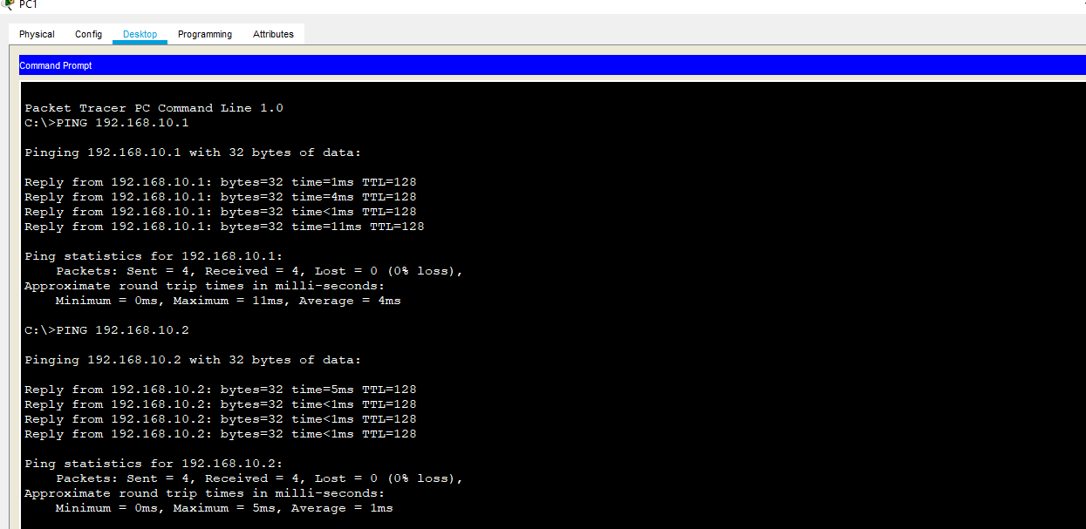

* ***PACKET TRANSFER REPORT:***

